Attention: this code could not run properly

**public** **class** Fibonacci { //declare a class named ‘Fibonacci’. It is ‘public’ instead of ‘private’, so that everyone could access it//

**public** **static** **void** main(String[] array){ //declare a non-return-value with a method named ‘main’. ‘static’ means we could call this method directly with its name, instead of creating an object of it. ‘String[] array’ is the arguments to the method, which means this method must be given an array of strings//

**int** input = 200; //declare an integer variable named ‘input’ and give it the value 200//

**int**[] fib = **new** **int**[20]; //declare a new integer array named fib. Assigned the array with 20 integers//

fib[0] = 0; //the first integer in the array ‘fib’ is 0//

fib[1] = 1; //the second integer in the array ‘fib’ is 1//

**int** arrayLength = fib.length; //declare an integer variable named ‘arrayLength’ and assign it with the value of ‘fib.legth’, which represents the length of the array ‘fib’//

**for** (**int** i=2; i<= arrayLength; i++){ //under the condition of integer i is equal to 2, while i is no larger than arrayLength; i = i+1//

fib[i] = fib[i-2] + fib[i-1]; //the ith integer in array ‘fib’ is equal to the sum of its former two integers//

**if**(fib[i] > input){ //only under the consition that the value of ith integer in array ‘fib’ is bigger than the input variable//

**int** multiple = 0; //integer variable multiple is 0//

multiple = i-1; //the variable multiple is assigned with the value of (i-1)th in array ‘fib’//

**break**; //the stop sign of the whole ‘for’ loop//

}

}

System.***out***.print("The Fibonacci series is: "); //print out ‘The Fibonacci series is: ’//

**for** (**int** i=0; i<= arrayLength; i++){ //under the condition of integer i is 0, and i is no bigger than the length of array ‘fib’, i = i+1//

System.***out***.print(fib[i] + " "); //print out the array ‘fib’ from its first integer to its ith integer, and double space//

}

}

}

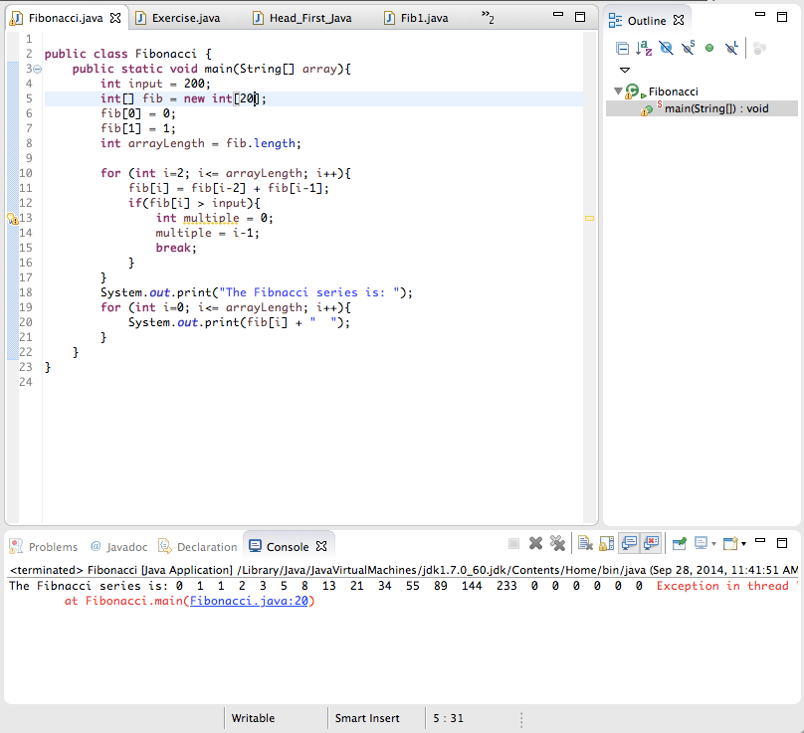

One thing I don’t understand is that why the code gives me 20 results, including 6 zeros. I think the problem is from System.***out***.print(fib[i] + " ");I probably should change fib[i] into like “the array.Length form its first integer to I integer”. However, I did not find the grammar for that.